Requirements

* L5 Accounting is the name of the company
* Create a website
* Create a database

ex:

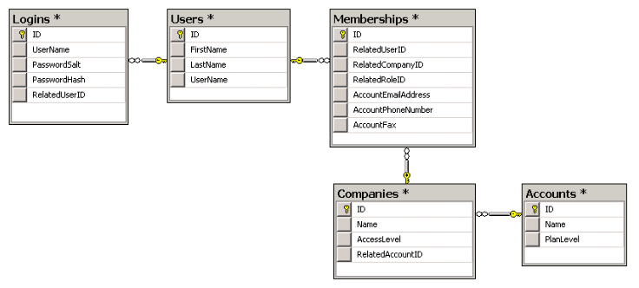

* Create a login system (Username & password)

ex:

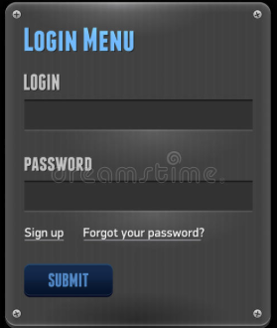

* Create a bank account using UML diagrams firs
* One account for sales and one esco account for sales tax collected per state.
* Track the amount of sales in the ‘Sales Account’ and the amount of sales taxes in the ‘Esco Account’ for every client depending on the sale point
* Send or display a monthly statement to the client account of the amount of sales taxes they owe to each state and their gross
* Five different point of sales (New York, Boston, New Jersey, Connecticut, Chicago)
* Five different clients (Food Truck[4], Luggage Company, Bread Company, Slider Sandwich, Battery)
* Owner of the company releases the tax money to the state
* Date of each transaction
* Send electronic receipts to the website owner
* Yearly tax report for the clients
* owner wants to login and have a record of all transaction(the amount of tax)
* we get a csv file from clients
* ability to send money to esco account directly
* 7 days to fix report(if clients write the wrong income)
* food truck (connecticut, new york, new jersey)
* pdf file to send to clients

**What we each know**

Stanley -> Java, HTML, CSS, JavaScript, Android

Duvall -> Java, Python, C++, HTML, CSS, SQL  
 Starlyn -> Java, C++, SQL, Android, Swift  
 Ziaul (Zia) -> Java, Python, Android, Swift  
 Junior -> Java, Android, Swift